VRA & VRO Integration with Chef

Revision 1.0

Date Issued:
06 September, 2017
Issued By:
Harshal Badgujar.

Related Documents:
Description | Location

Revision History
Revision | Date Issued | Author | Change Description
1.0 | 06-September-2017 | Harshal Badgujar. | Initial draft

Table of Contents

1. Introduction 4
1.1 Download chef plugin for vRO 4
2. Adding and configuring chef plugin to vRO 4
2.1 Pre-requisites 4
2.2 Configuring chef with vRO 4
3. Perform chef operations through vRO 7
3.1 Configure chef server with vRO 7
3.2 Add chef client into vRO 9
3.3 Add runlist and run the components on chef client 10
3.4 Different chef-related operations through vRO 13
4 Calling vRO workflow from vRA 14
4.1 Create Blueprint1 14
4.2 Create Entitlement 16
4.3 Create Event Subscription 17
4.4 Run the blueprint from catalog 20
References 21

1. Introduction :
- This guide will help you to configure chef plugin with vRealize Orchestrator (vRO) and perform basic chef related operations through vRO interface.
- This allows vRO to automate common tasks in Chef as well as integrate with cloud automation solutions like vRealize Automation.
- After following this, there is no need to create any custom workflows to perform basic chef related operations.

1.1 Download chef plugin for vRO
- Go to https://marketplace.vmware.com/vsx/solutions/chef-plugin-for-vrealize-orchestrator
- Click on Try and download the .vmopp chef plugin file

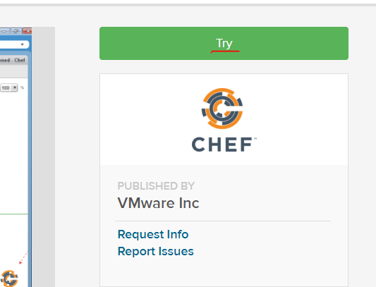

2. Adding and configuring chef plugin to vRO

2.1 Pre-requisites :
- vRealize Orchestrator installed and configured.
- Chef server and workstation installed and configured.
- Chef plugin should be downloaded on local machine.
- At least one admin user created on Chef Server and the PEM private key (root.pem from workstation should work) available.

2.2 Configuring chef with vRO :

I) Open the vRealize Orchestrator Control Center (Url for local lab : https://10.136.12.20:8283/vco-controlcenter/#/) and login as root and password set (root/gsLab!23 in local lab).
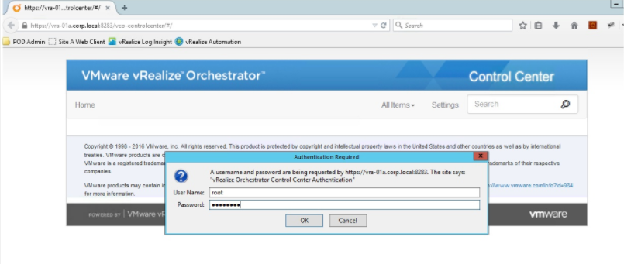
II) Browse to the plug-ins then click Manage plug-ins.
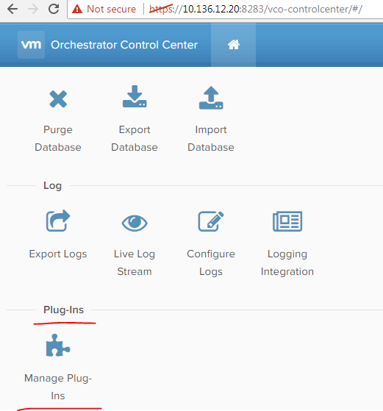

III) Browse to the Chef plugin from local machine and click install.

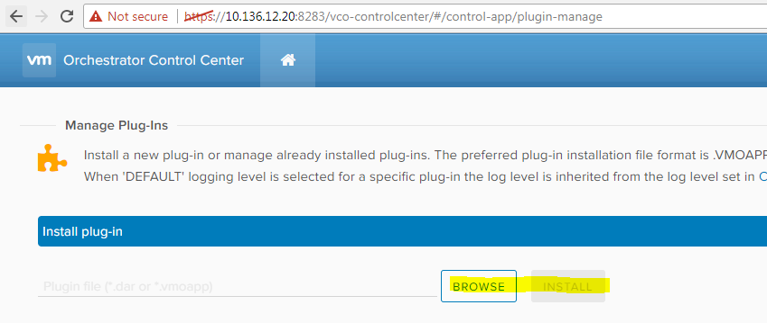

IV) Accept the EULA and click install.
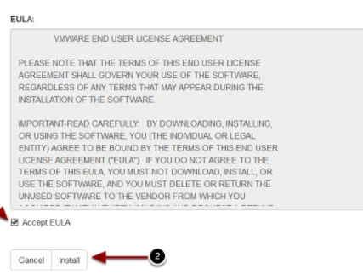

V) Now vRO needs to be restarted. Click on the Home link.

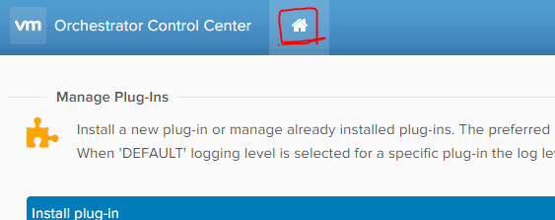

VI) Now click startup options and click Restart.

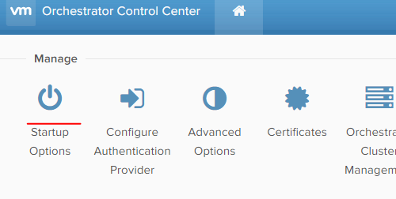

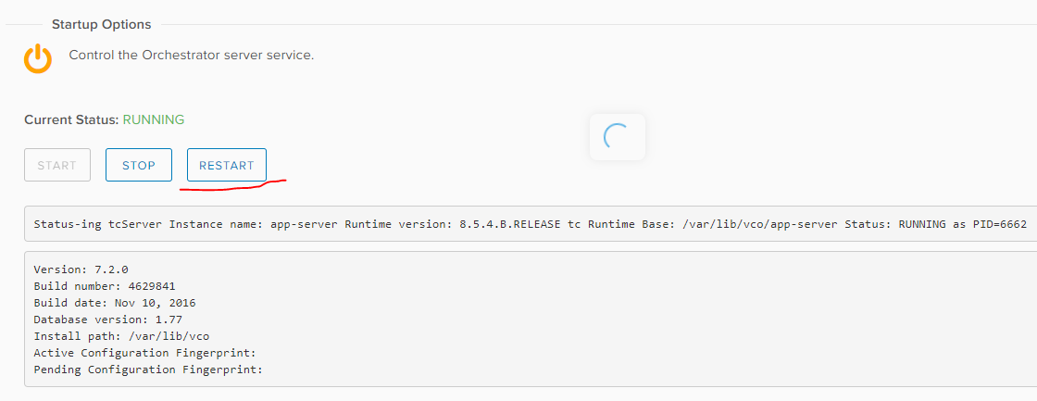

VII) Now login to the vRO client and change to RUN view then go to the plugins tab to verify that the Chef Plugin was installed.

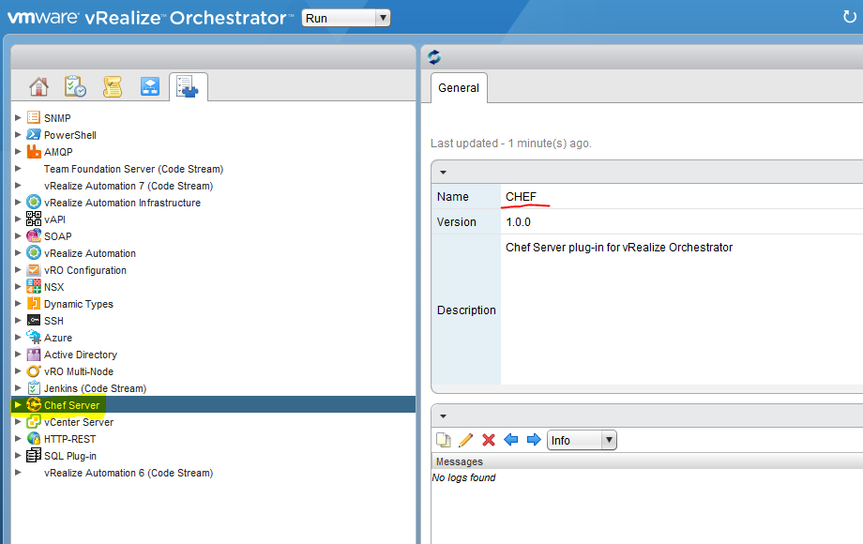
3. Perform chef operations through vRO

3.1 Configure chef server with vRO

I) Now switch to Design tab in vRO. Go to the Workflows and click on the Library folder, then CHEF then Configuration and run the Add Chef Host Workflow. Click on the green symbol circled red.

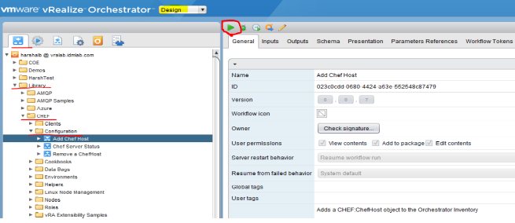
II) Chef plugin is installed on vRO. Now, you need to add chef server into vRO to perform any chef operations. You will need chef server configured on accessible VM with root/admin access.
Then you will need PEM file from server (root.pem can be found on chef workstation copied from server).

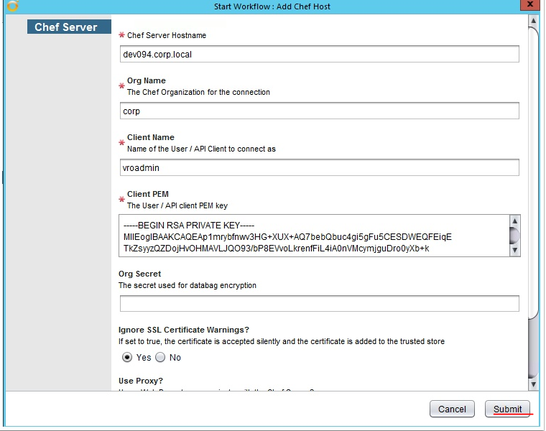
III) Add the correct details for chef server hostname, chef organization name, any client name.
Then copy root.pem to client PEM box. Click on Ignore SSL Ceritificate and click Submit.

You can check the status of workflow and completion status in General tab and can check logs for any issues in Logs tab.

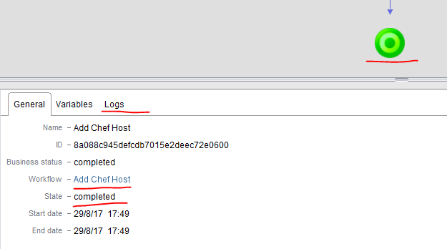

3.2 Add chef client into vRO

I) Next, you can add chef client and configure it with chef server.
And then you can later add runlist to that client and then run that runlist.

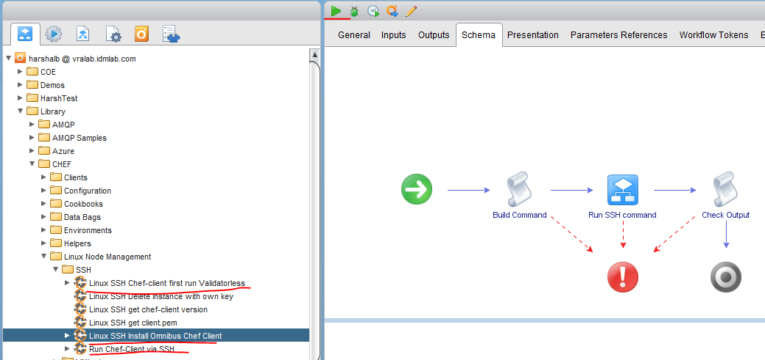

II) For that, you need to run the workflows as shown in image above.
First, go to Linux SSH Install Omnibus Chef Client. Click on green triangle for run. You will need to have one machine ready and accessible through SSH.

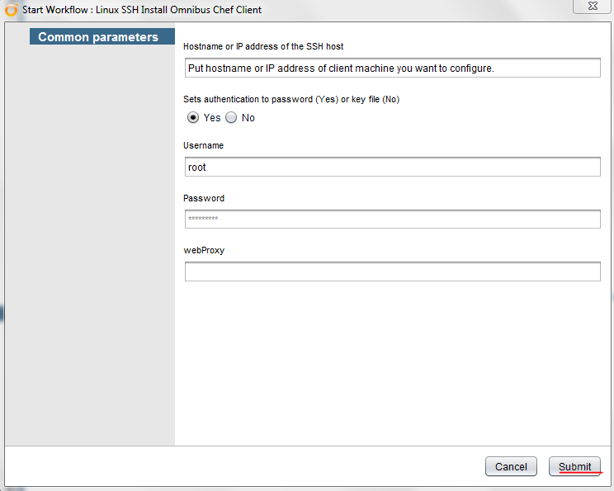

III) Verify that chef client is added and configured successfully with chef server.

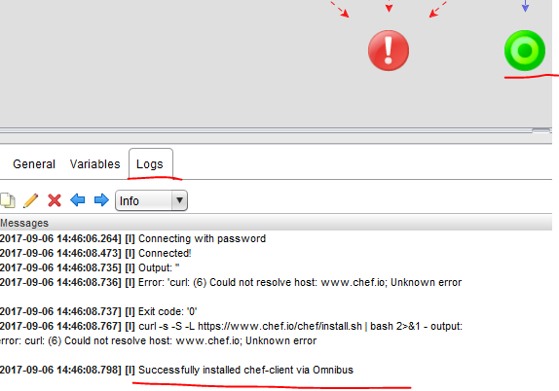

3.3 Add runlist and run the components on chef client

I) Now, click on this workflow to run chef-client for the first time and add runlist to it first.

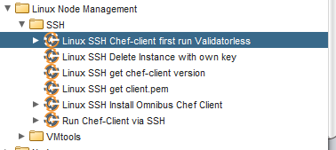

II) After clicking run, you will be asked to provide few details as shown below. :

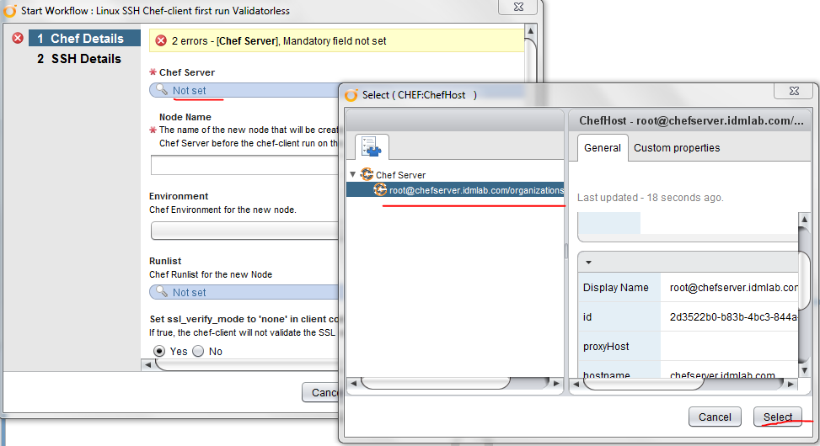
Click on Not set, it will give you option to select chef server we added previously. Click on Select.

III) Add the node name of chef client we added in the last step.
Click on Not Set for Runlist. It will give you option to add role/s from available list of roles present on chef server.
Then click on Next.

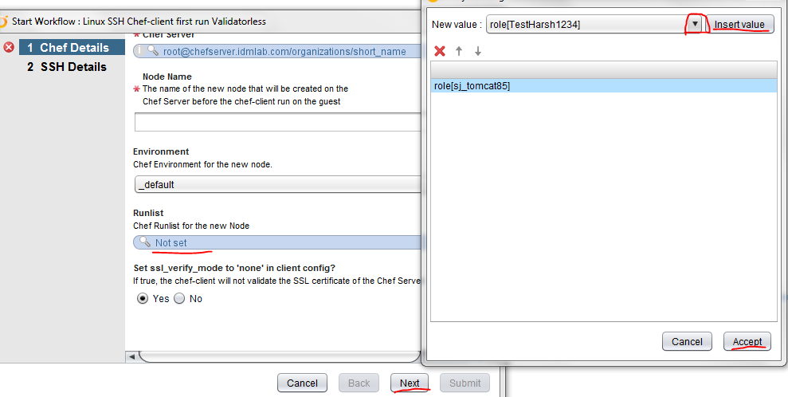

This is how it should look like.

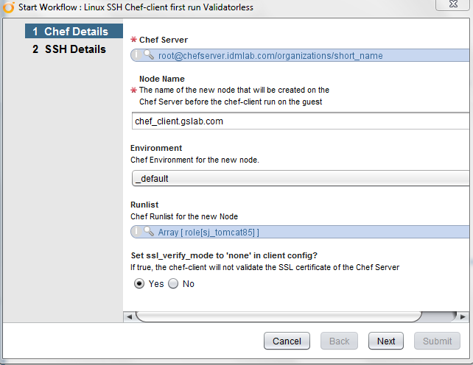

IV) On the next page, fill the details for chef client added previously and click on Submit.

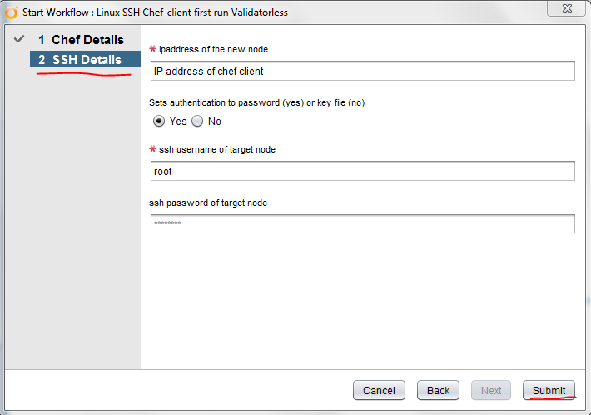

Check the status of workflow in the logs.

V) If you want to run role/cookbook on same node again, click on Run Chef-Client via SSH workflow for further runnings.

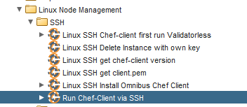

3.4 Different chef-related operations through vRO

These are the different operations you can perform once chef host is successfully added into vRO.

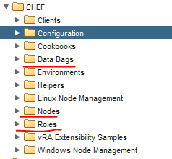

You can retrieve/create/delete roles on chef server, perform operations related to Data Bag, Environments etc..

This is just an overview of how to incorporate chef-related operations into vRO.

4. Calling vRO workflow from vRA :

Now we have to integrate workflow created in vRO into vRA.
For that, we have to create blueprint in vRA first.

Login to vRA UI.
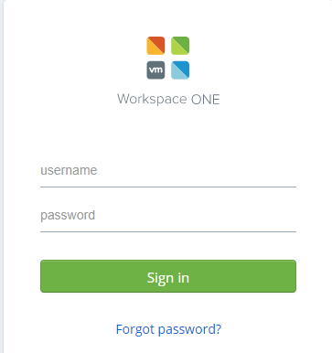

4.1 Create Blueprint

I) Go to Design -> Blueprints.
Click on New button. Give name and description.

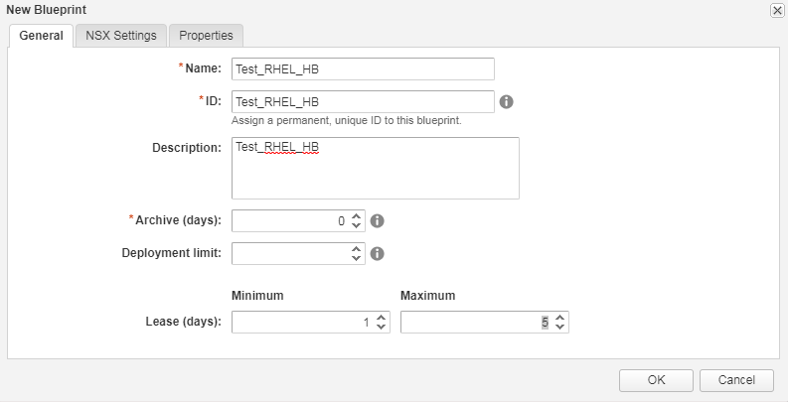

II) Drag and drop vSphere Machine to canvas.

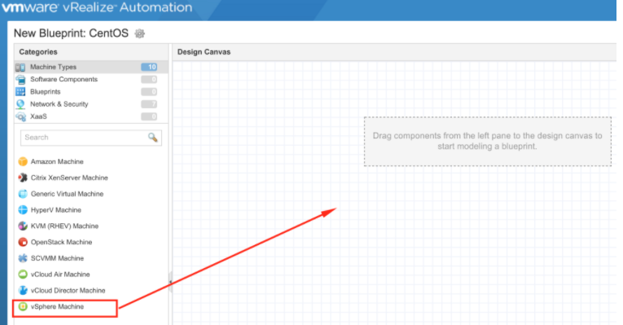

III) Fill out information appropriately.

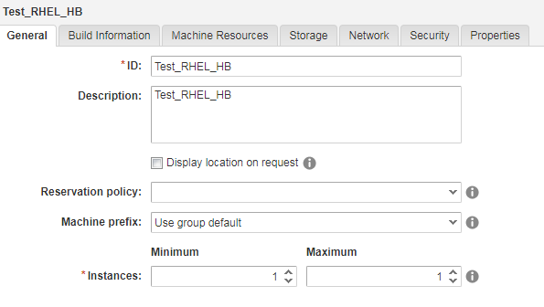

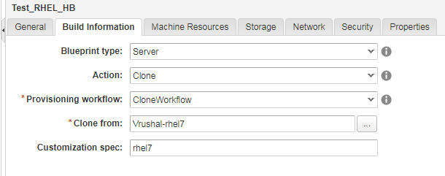

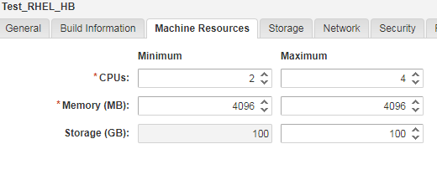
IV) Click publish after finishing creating blueprint.

4.2 Create Entitlement
Now, create Entitlement to be able to run the blueprint created above.

I) To create a new entitlement go to Administration tab –> Catalog Management –> Entitlements. Click the “New” button to add a new entitlement.

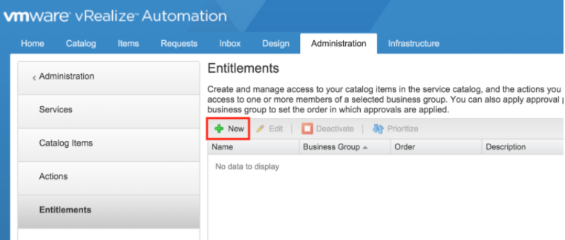

II) Fill details as shown below. :
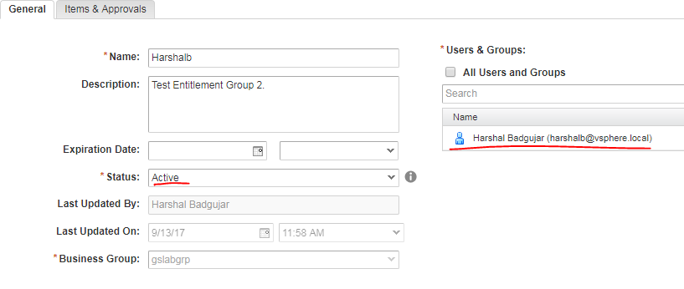
III) Next, under the “Items & Approvals” tab, we get to pick which things this user(s) will have access to. I chose to entitle this user to my “Private Cloud” service. I am giving permission to user to perform all the actions.
Choose the blueprint that will be entitled to this (that we created in earlier step).

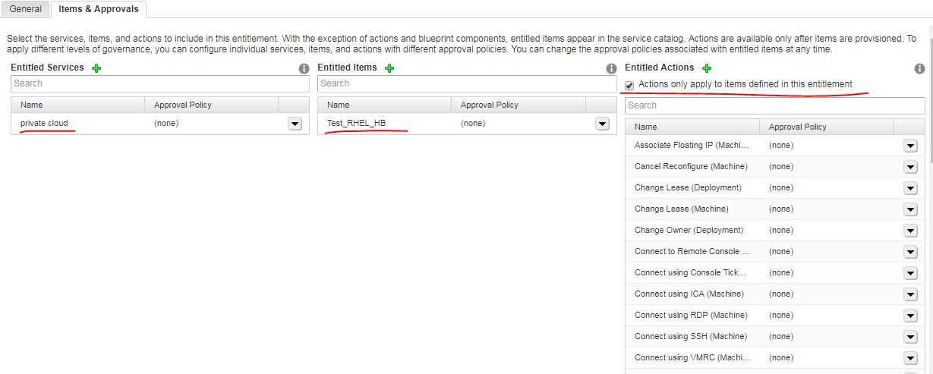

IV) Check if you can see your blueprint listed in Catalog tab of vRA.
I have created Test_RHEL_HB visible in Catalog as shown below. :

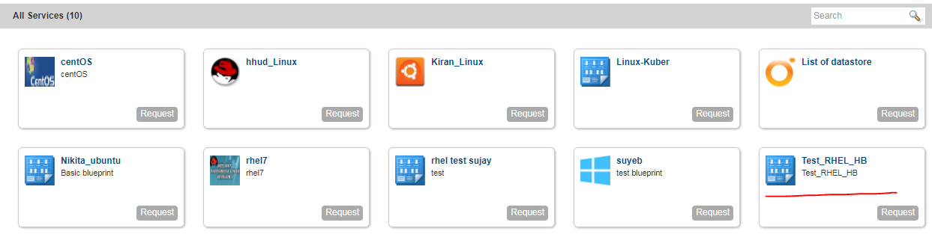

4.3 Create Event Subscription

Now, we need to create subscription event to call the workflow event from the blueprint created above.

I) Go to the Administration Tab –> Events –> Subscriptions.
Click the “New” button.
Choose event topic as Machine provisioning.

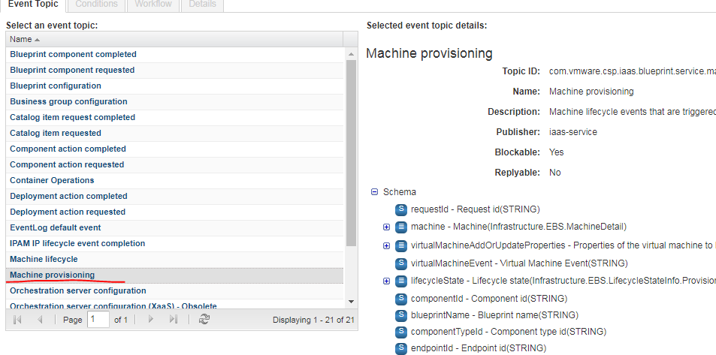

II) We are going to “Run based on conditions” this event.
Choose conditions suitable to your need.

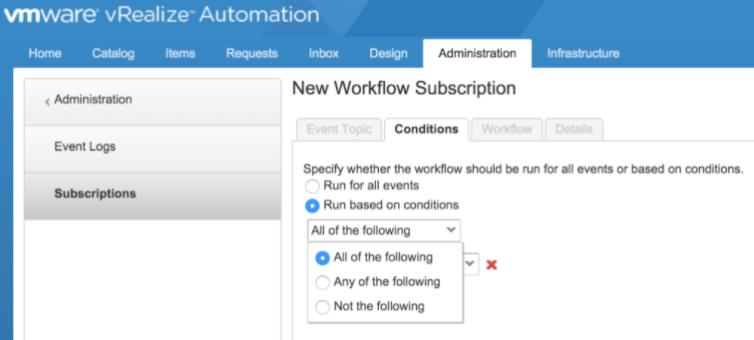
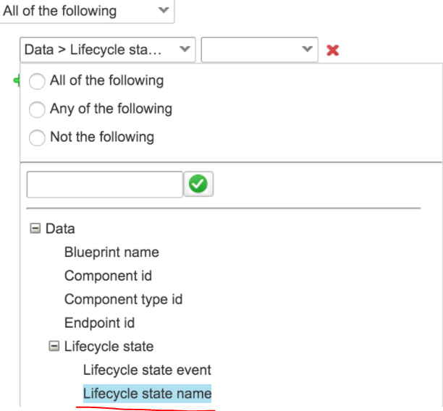

III) I have chosen these conditions. :

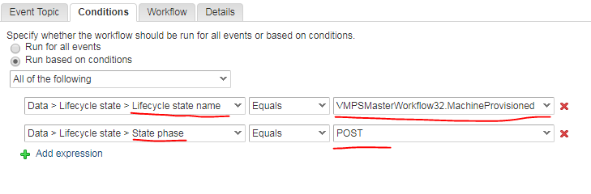
IV) Now, select workflow from workflow tab that you want to be called from this event.

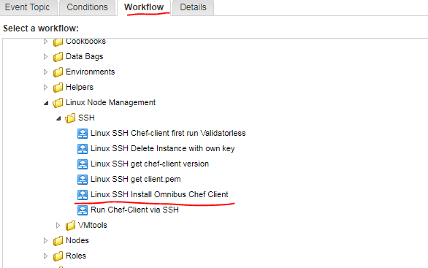

V) Give name, description and blocking status in details tab and click Finish.

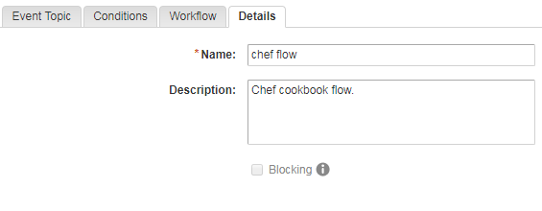

VI) Click Publish after finishing creating subscription event.

4.4 Run the blueprint from catalog

I) Click on Request.
See the status of your blueprint in Requests tab.

Reference links :

https://theithollow.com/2016/01/11/vrealize-automation-7-guide/

